Shift Handover Application for Nurses

Submitted in partial fulfillment of the requirements of the degree

**BACHELOR OF ENGINEERING IN INFORMATION TECHNOLOGY**

By

|  |  |  |
| --- | --- | --- |
| UID |  | NAME |
| 120IT1214A | : | Patole Kunal Kishor |
| 120IT1108A | : | Pawar Herschel Pravin |
| 120IT1085A | : | Raj Aditya Krishna |
| 121IT3085A | : | Rathod Chandan Sudhir |

Supervisor

**Prof. Manivannan**



**Department of Information Technology**

**Mahatma Gandhi Mission's College of**

**Engineering & Technology**

**Kamothe, Navi Mumbai - 410 209**

**University of Mumbai**

**(AY 2020-21)**

# **CERTIFICATE**

This is to certify that the Project entitled “Shift Handover Application for Nurses” is a bonafide work of **Patole Kunal Kishor (53), Pawar Herschel Pravin (54), Raj Aditya Krishna (69), Rathod Chandan Sudhir (72)** submitted to the University of Mumbai in partial fulfillment of the requirement for the award of the degree of “Bachelor of Engineering” in “Information Technology”

|  |  |  |  |
| --- | --- | --- | --- |
| Roll No. |  | NAME | Sign |
| **53** | : | Patole Kunal Kishor | ____________ |
| **54** | : | Pawar Herschel Pravin | ____________ |
| **69** | : | Raj Aditya Krishna | ____________ |
| **72** | : | Rathod Chandan Sudhir | ____________ |

(Prof. ____________)

Supervisor

|  |  |
| --- | --- |
| (Prof. Dr. Swati Sinha)  Head of Department | (Prof. Dr. Geeta S. Latkar)  Director |

# **PROJECT APPROVAL**

This Project entitled “Shift Handover Application for Nurses” by **Patole Kunal Kishor (53), Pawar Herschel Pravin (54), Raj Aditya Krishna (69), Rathod Chandan Sudhir (72)** is approved for the degree of Bachelor of Engineering in Information Technology.

|  |  |
| --- | --- |
|  | Examiners |
|  | 1. ______________   (Internal Examiner Name & Sign) |
|  | 1. ______________   (External Examiner Name & Sign) |

Date:

Place: MGMCET, Kamothe

# **CONTENTS**

**CERTIFICATE** 2

**PROJECT APPROVAL** 3

**CONTENTS** 4

**LETTER OF TRANSMITTAL** 5

**ACKNOWLEDGEMENT** 6

ABSTRACT 7

**LIST OF TABLES** 8

Introduction 8

Feasibility Study 9

Hardware And Software Requirements 10

System Purpose 11

Scope 12

Features 13

Overview 14

Technologies Used 15

EXISTING SYSTEM 17

DISADVANTAGES OF CURRENT SYSTEM 17

CHARACTERISTICS OF THE PROPOSED SYSTEM 17

**FLOWCHART** 18

**ER DIAGRAM** 21

**SCREENSHOTS** 22

**CONCLUSION** 32

**BIBLIOGRAPHY** 33

**TABLE OF FIGURES** 35

**FUTURE SCOPE** 36

# **LETTER OF TRANSMITTAL**

This report is about our SHAN: Shift Handover Application for Nurses project. It contains all of the project's necessary data.

The article was written to give all of the necessary facts and information for anyone to rebuild or improve our product on their own. It provides critical information about the project's essential structure as well as sufficient information to alter the project to whatever demands may arise. The primary goal of the project was to assist nurses in rapidly passing information to the next nurse that arrived and to have a dependable source of information should the need arise.

Please contact us if you have any more queries or would want me to give additional analysis. Thank you for reading the study and making recommendations. We look forward to hearing from you.

Sincerely,

SHAN Team

# **ACKNOWLEDGEMENT**

The success and final outcome of this project required a lot of guidance and assistance from many people and we are extremely fortunate to have got this all along the completion of our project work. Whatever we have done is only due to such guidance and assistance and we would not forget to thank them.

It is matter of great pleasure for us to submit the project report on “Shift Handover Application for Nurses”, as a part of our curriculum.

We would like to thank our HOD, Dr. Swati Sinha, for allowing us to work on this paper. We would like to express our gratitude to our Director, Dr. Geeta Lathkar, who has significantly inspired and encouraged us. It was a pleasure to collaborate on the report with our Vice Principal, Dr. V.G. Sayagavi.

Last but not least, a special thanks goes to my team members, who assisted me in gathering material and making recommendations to help us finish our project.

# ABSTRACT

Shift Handover Application for Nurses is a JavaScript-based tool. This project divides its user types primarily into two groups: nurses and administrators. This initiative will assist nurses in saving energy and time when changing shifts. The data is automatically saved and retrieved, eliminating the need for nurses to spend extra time discussing patient changes.

# **LIST OF TABLES**

## Introduction

Nurses have a difficult task in treating patients. They frequently supervise 30 or more patients. They must remember all of the medications they supplied to the patients, as well as all of the processes they performed, such as changing saline, measuring blood pressure and temperature, and several other jobs, in addition to always recording them so they do not give out incorrect information.

There is a need to digitize this procedure and employ new technologies to reduce their workload. The project intends to do the same thing.

## Feasibility Study

The following feasibility studies were conducted

1. Technical feasibility
   1. Technical: Hardware and software
   2. Existing or new technology
   3. Manpower
   4. Site analysis
   5. Transportation
2. Financial feasibility
   1. Initial investment
   2. Resources to procure capital: Banks, investors, venture capitalists
   3. Return on investment
3. Market feasibility
   1. Type of industry
   2. Prevailing market
   3. Future market growth
   4. Competitors and potential customers
   5. Projection of sales
4. Organizational feasibility
   1. The organizational structure of the business
   2. Legal structure of the business or the specific project
   3. Management team’s competency, professional skills, and experience

It was discovered that the project is technically possible, financially viable, has a market, and the program is simple to use.

## Hardware And Software Requirements

* Hardware Requirement:
  + CPU
    - Intel Xeon E3-1245 v2 (4c/8t, 3.40GHz)
  + RAM
    - 8GB
  + Storage
    - At least 30GB
  + Networking
    - At least 100mbps up and down
* Software requirement:
  + OS
    - Linux or Windows
  + Node.JS and NPM
  + The whole software stack
  + Version control
    - Git

## System Purpose

Our software's objective is to save data (for example, patient details, vital signs, rhythm, and so on) and then provide it to the nurse and doctor. This not only saves time by not having to perform all of the work manually, but it also makes it easier because the data is saved with timestamps and the nurse's details. Instead of keeping notes, nurses may focus on working hard and providing excellent care to their patients. Our program reduces the amount of communication required while changing shifts.

## Scope

This project's scope is fairly broad since a similar system may be utilized for other wards and data recording as well. Among them are:

* It is simple to use in prosthetics training for measuring progress.
* It employs safe techniques of storing and retrieving passwords and is faster than spoken communication.
* It is more precise since it uses timestamps.

## Features

* safe
* simple to use
* dependable
* data exportable

## Overview

The following user kinds and functionalities are accessible in the software.

* Superadmin
  + Administrators are added by the Superadmin
* Admin
  + Administrators add nurses
* Nurse
  + Enter patient information
  + Access patient details
  + Edit patient details

## Technologies Used

* backend
  + - bcryptjs
      * + storing and retrieving passwords
    - cookie-parser
      * + Parsing cookies
    - cors
      * + Cross-Origin Resource Sharing
    - dotenv
      * + load environment variables from `.env` file
    - express
      * + node js web application framework that provides broad features for building web and mobile applications
    - mongoose
      * + manipulates the documents of the collection of the MongoDB database
    - swagger-ui-express
      * + generate API docs
    - yamljs
      * + YAML parser and encoder
* frontend
  + - react
      * + component-based front-end library responsible for the view layer of the application
    - react-bootstrap
      * + CSS styling library used for react
    - react-router-dom
      * + routing pages properly
    - react-redux
      * + used for building the user interface
    - axios
      * + promise based HTTP client for the browser and Node.js
* MongoDB
  + - Database for storing all the information

## EXISTING SYSTEM

You may do it the old-fashioned way with paper and ink, or you can create specialized software for each facility. Some large hospitals are already in the process of digitizing their systems.

## DISADVANTAGES OF CURRENT SYSTEM

1. The existing system is time-consuming and inefficient.
2. It necessitates the nurse physically recalling all of the patients' information and relaying it to the other nurse.
3. They can forget some little facts, which could lead to issues later on.

## CHARACTERISTICS OF THE PROPOSED SYSTEM

Our program outperforms the present system in the following ways.

1. It takes less time.
2. The nurses merely need to enter the information by phone or computer.
3. It is quite effective.
4. If you use the website, you do not need to install anything.

# **FLOWCHART**

Figure 1: Main Process

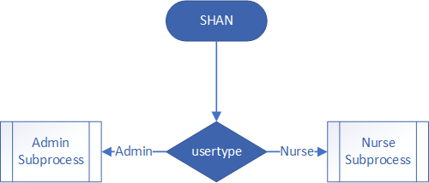

Figure 2: Admin Subprocess

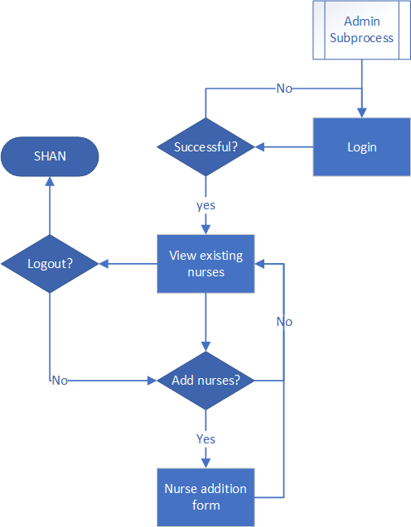

Figure 3: Nurse Subprocess

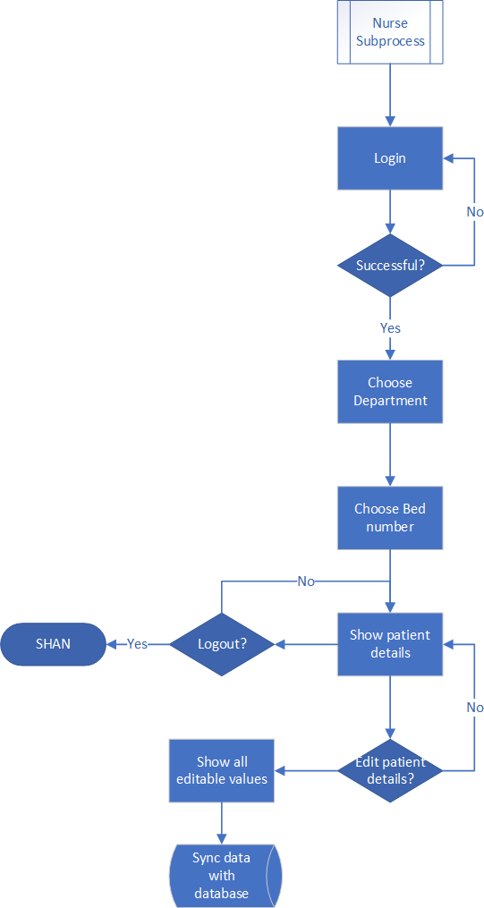

# **ER DIAGRAM**

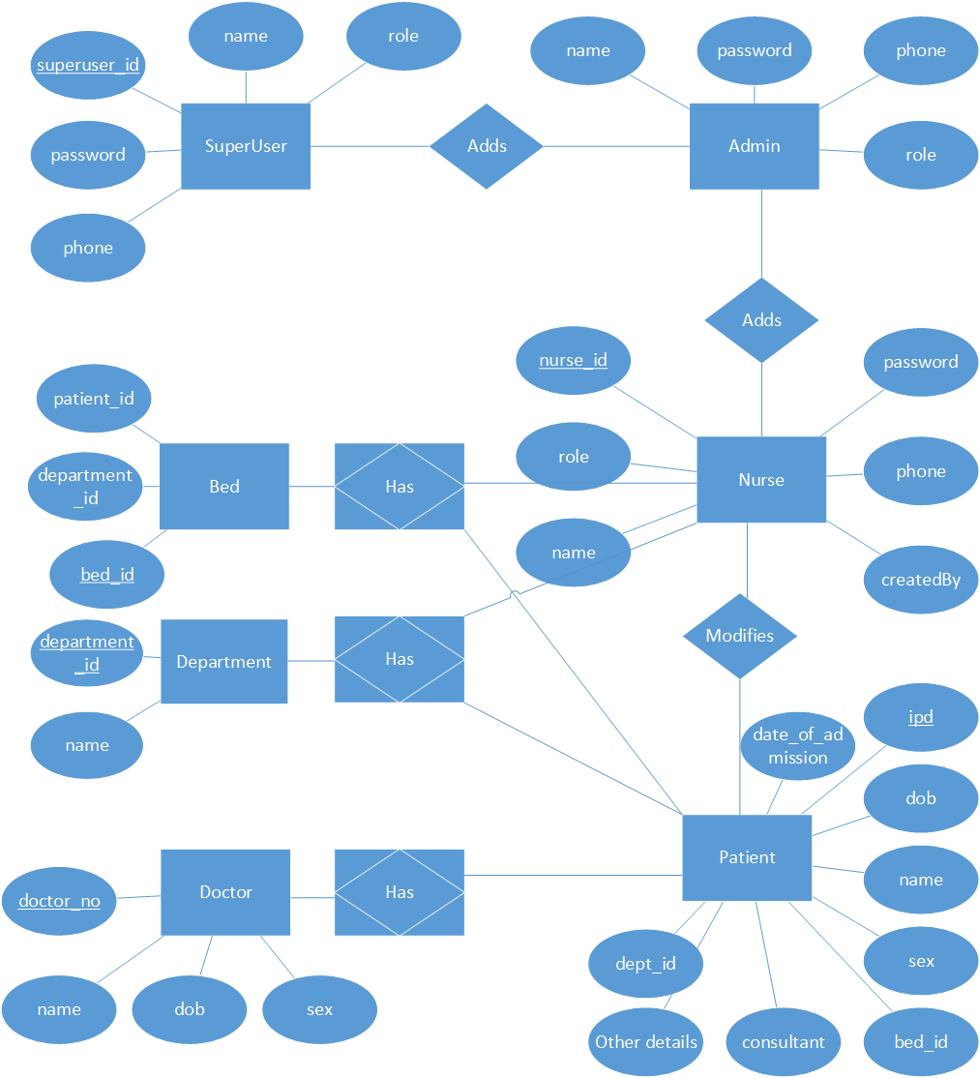

# **SCREENSHOTS**



Figure 4: Front page

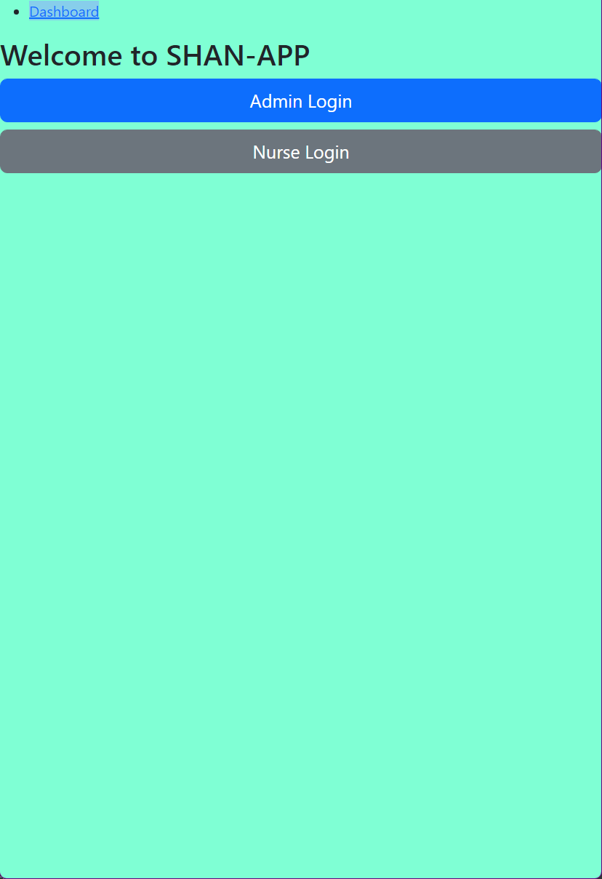

Figure 5: Dashboard

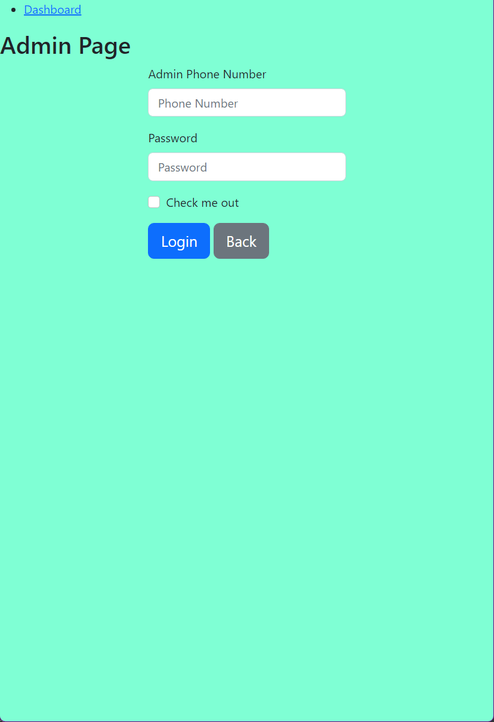

Figure 6: Admin Login

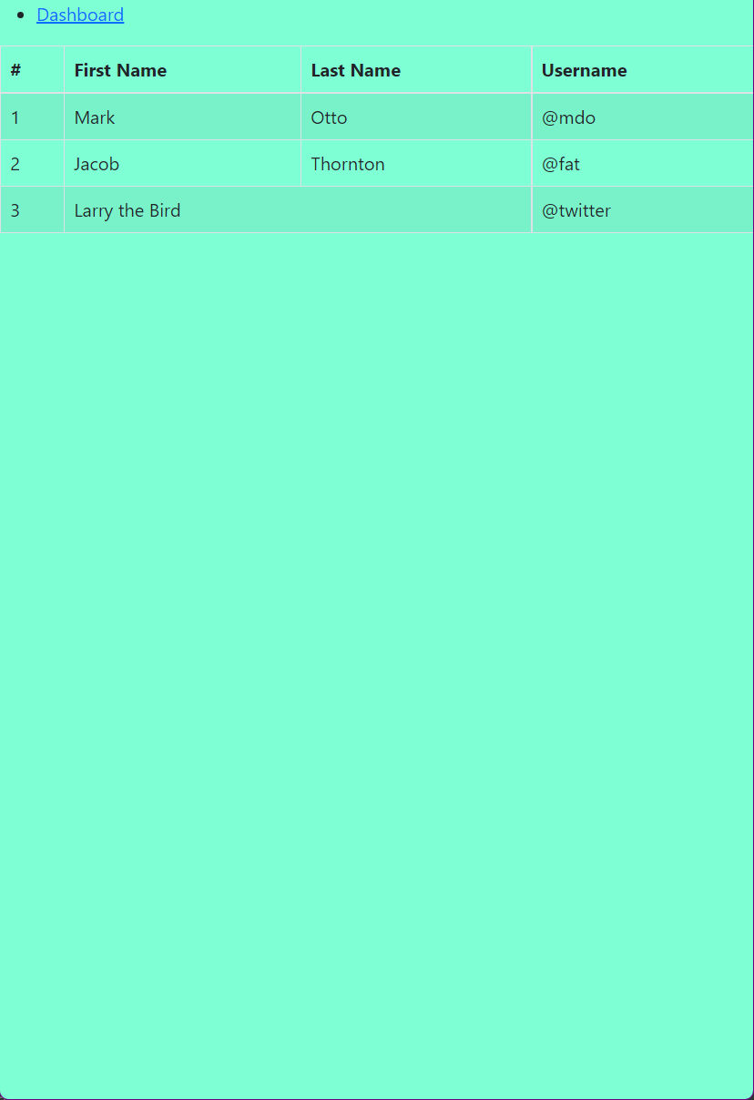

Figure 7: All Nurses

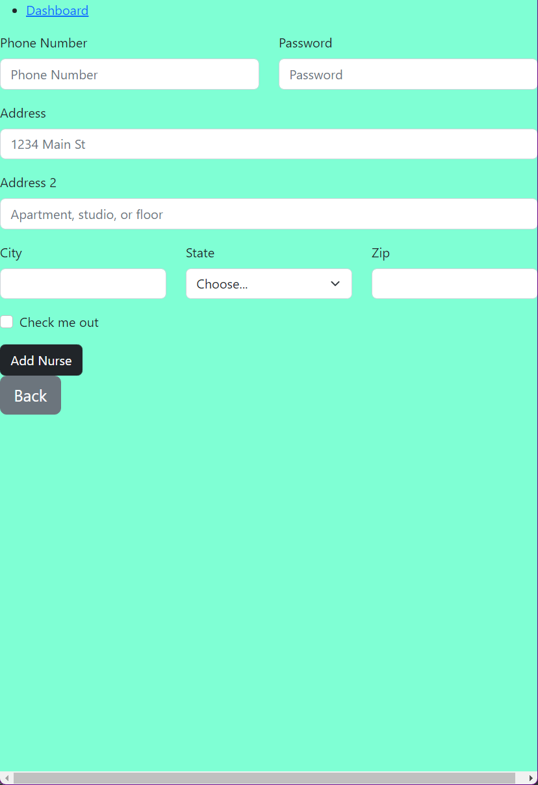

Figure 8: Add nurses

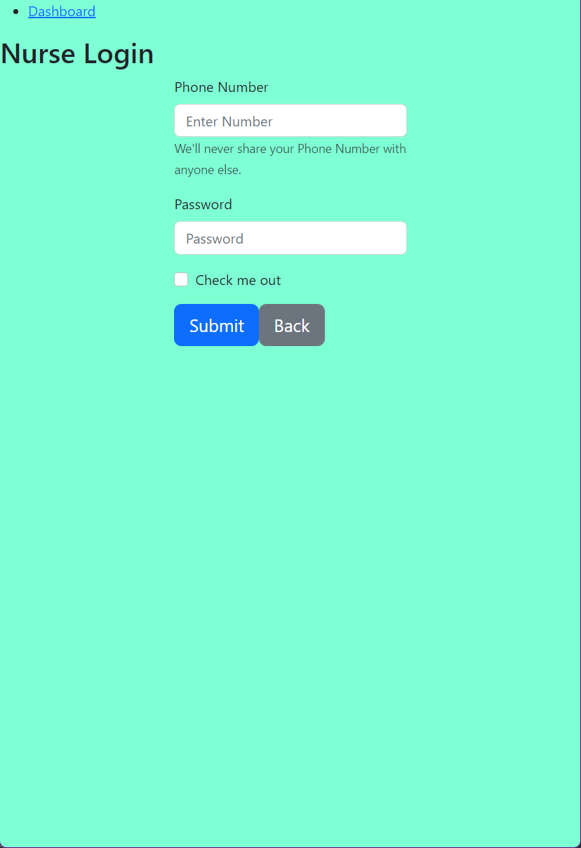

Figure 9: Nurse Login

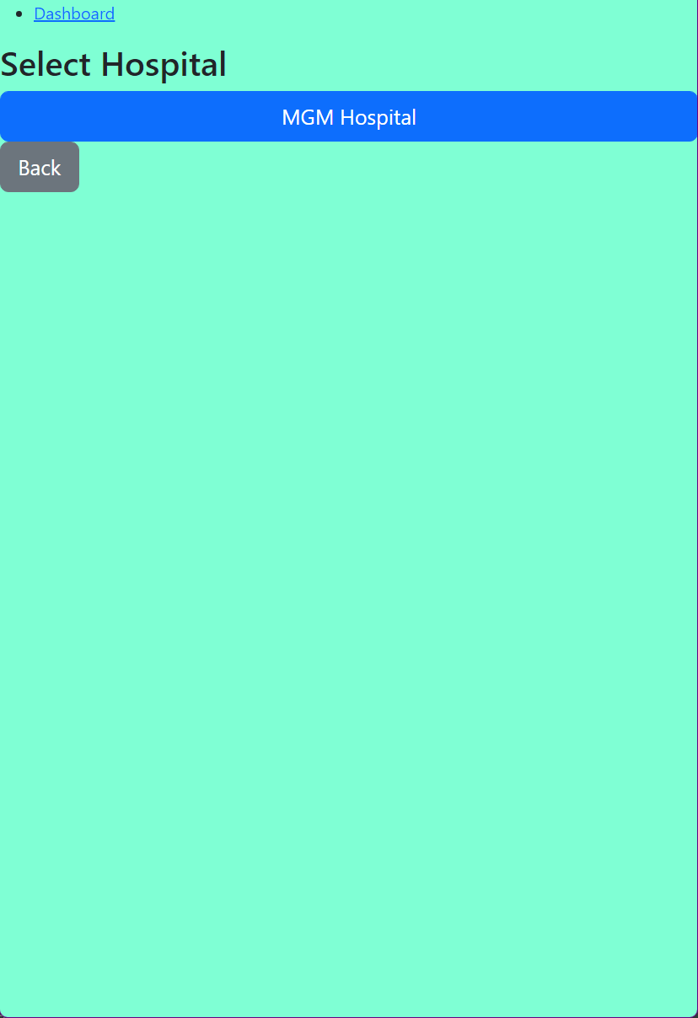

Figure 10: Select Hospital

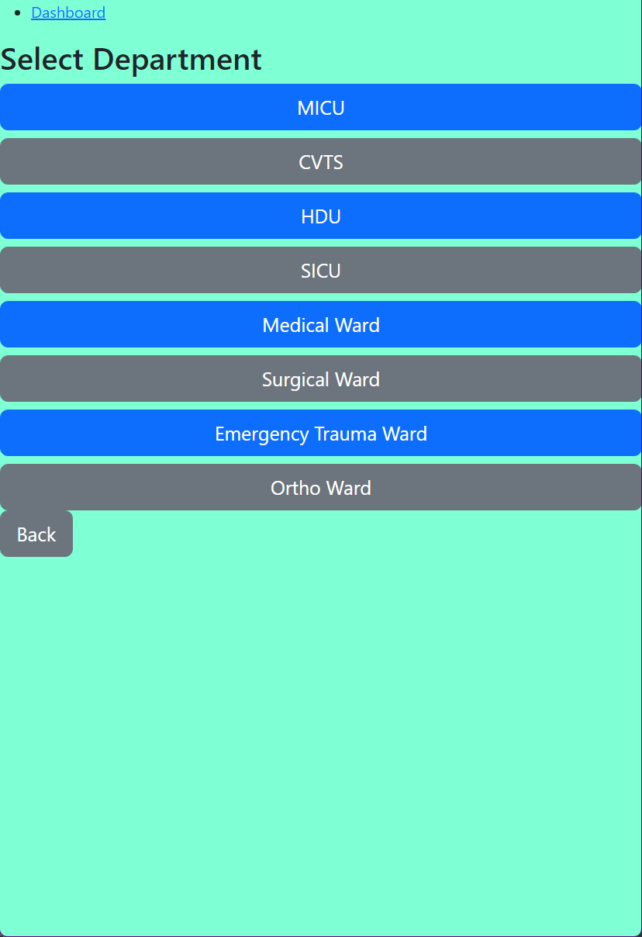

Figure 11: Select Department

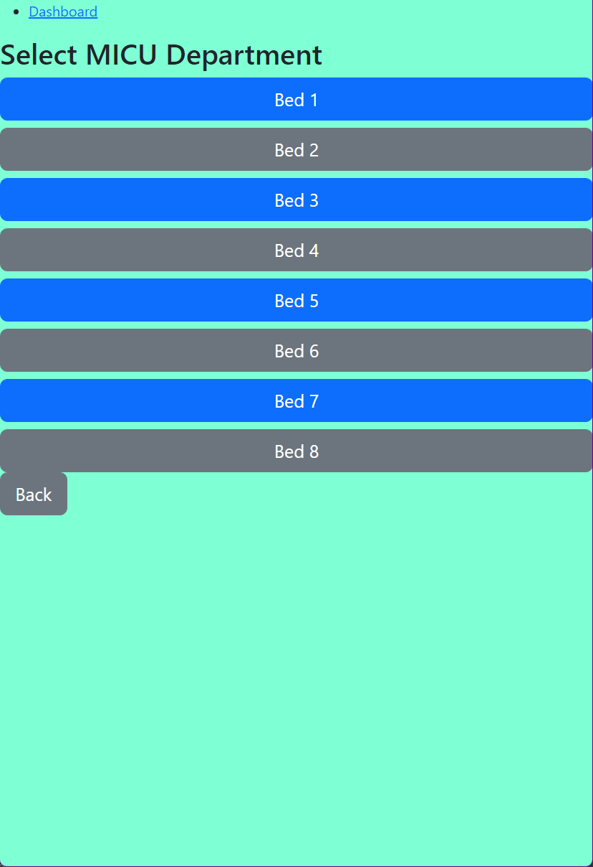

Figure 12: Select Bed

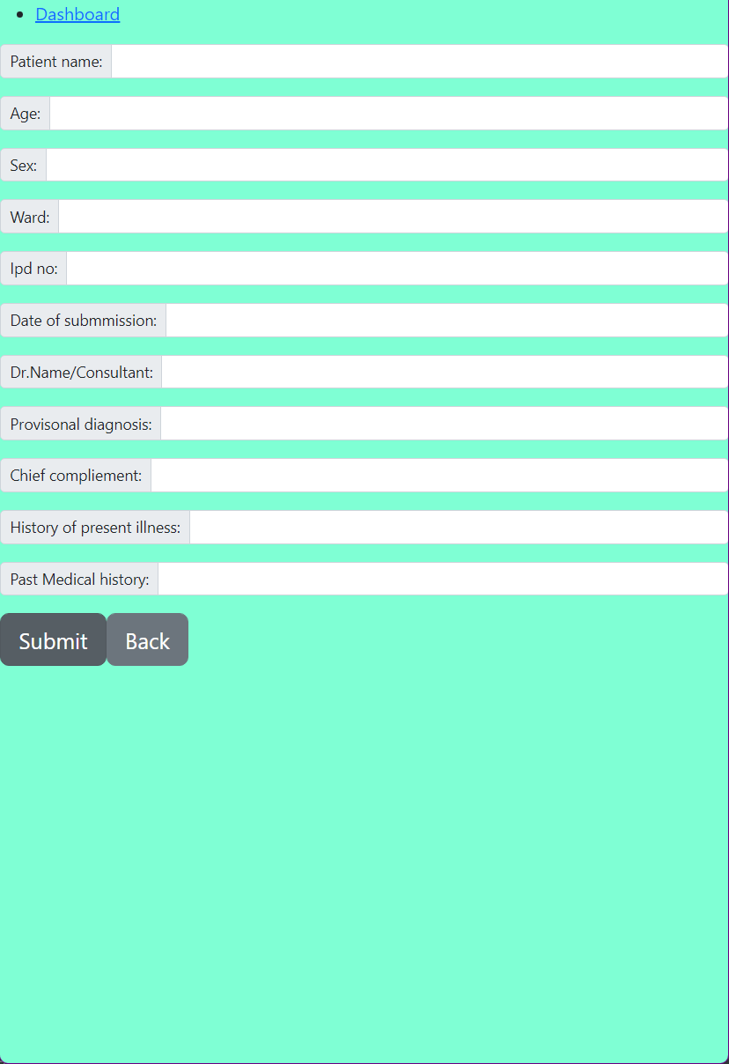

Figure 13: Edit Patient Details

# **CONCLUSION**

The Shift Handover Application for Nurses is written in JavaScript and fits the requirements of the system for which it was designed. The system has achieved a stable state in which all bugs have been eliminated. The system runs at a high degree of efficiency, and all teachers and users are aware of its benefits. The system addresses the challenges it was designed to solve for the needed specification.

# **BIBLIOGRAPHY**

*4.x API*. (n.d.). Retrieved from Express: https://expressjs.com/en/4x/api.html

*dcodeIO/bcrypt.js*. (n.d.). Retrieved from Github: https://github.com/dcodeIO/bcrypt.js

*expressjs/cookie-parser*. (n.d.). Retrieved from GitHub: https://github.com/expressjs/cookie-parser#readme

*expressjs/cors*. (n.d.). Retrieved from GitHub: https://github.com/expressjs/cors#readme

*Get Started with Atlas*. (n.d.). Retrieved from MongoDB: https://www.mongodb.com/docs/atlas/getting-started/

*Getting Started*. (n.d.). Retrieved from MongoDB: https://www.mongodb.com/docs/manual/tutorial/getting-started/

*Getting Started*. (n.d.). Retrieved from mongoose: https://mongoosejs.com/docs/

*Getting Started*. (n.d.). Retrieved from React: https://reactjs.org/docs/getting-started.html

*Getting Started*. (n.d.). Retrieved from AXIOS: https://axios-http.com/docs/intro

Gray, D. (n.d.). *React Axios API Requests | Axios with React JS Tutorial*. Retrieved from YouTube: https://youtu.be/ZEKBDXGnD4s

Gyan, C. (2021, June 6). *Learn React Js for beginners in Hindi 🔥🔥*. Retrieved from YouTube: https://youtu.be/MfhZJcTOy1A

Gyan, C. (2022, April 5). *Learn Redux Toolkit in one video 🔥🔥🚀 ( Hindi )*. Retrieved from YouTube: https://youtu.be/XwGNhppX4as

Hamdare, S., & Sen, S. H. (2016). *Database Management System.* Vikas.

*Introduction*. (n.d.). Retrieved from react-bootstrap: https://react-bootstrap.github.io/getting-started/introduction

*Learn PWA*. (n.d.). Retrieved from web.dev: https://web.dev/learn/pwa/

*MongoDB Node Driver*. (n.d.). Retrieved from MongoDB: https://www.mongodb.com/docs/drivers/node/current/

*motdotla/dotenv*. (n.d.). Retrieved from GitHub: https://github.com/motdotla/dotenv#readme

*nodeca/js-yaml*. (n.d.). Retrieved from GitHub: https://github.com/nodeca/js-yaml

*Quick Start*. (n.d.). Retrieved from REMIX / REACT ROUTER: https://v5.reactrouter.com/web/guides/quick-start

*React Redux Quick Start*. (n.d.). Retrieved from React Redux: https://react-redux.js.org/tutorials/quick-start

*React Tutorial*. (n.d.). Retrieved from W3Schools: https://www.w3schools.com/REACT/DEFAULT.ASP

SHOWS, G. (2022, February 25). *React JS (Hindi)*. Retrieved from YouTube: https://youtube.com/playlist?list=PLbGui_ZYuhignjLLXTJWkRJKN-SgAqClL

Shows, G. (2022, January 20). *REACT ROUTER V6* . Retrieved from YouTube: https://youtu.be/x25vdOsMaqY

Souza, D. (2020, September 1). *Documenting your Express API with Swagger*. Retrieved from LogRocket Blog: https://blog.logrocket.com/documenting-your-express-api-with-swagger/

*Welcome to the MongoDB Documentation*. (n.d.). Retrieved from MongoDB: https://www.mongodb.com/docs/

# **TABLE OF FIGURES**

Figure 1: Main Process 18

Figure 2: Admin Subprocess 19

Figure 3: Nurse Subprocess 20

Figure 4: Front page 23

Figure 5: Dashboard 24

Figure 6: Admin Login 25

Figure 7: All Nurses 26

Figure 8: Add nurses 27

Figure 9: Nurse Login 28

Figure 10: Select Hospital 29

Figure 11: Select Department 30

Figure 12: Select Bed 31

Figure 13: Edit Patient Details 32

# **FUTURE SCOPE**

Our project may be enhanced in a variety of ways, including

1. The addition of readily editable hierarchy.
2. Improved and more user-friendly interface.
3. Displaying the most current 24-hour data.
4. Displaying historical data.
5. Allowing nurses to amend critical data more quickly.
6. Image server for image storage.